
Standard Work Day and Reporting Resolution for Elected and Appointed Officials
Received Date

Please type or print clearly in blue or black ink

Employer Location Code
SEE INSTRUCTIONS FOR COMPLETING FORM ON REVERSE SIDE
4 0 3 3 2

RS 2417-A
(Rev.12/23)

BE IT RESOLVED, that the Village of Florida
/ 40332
(Name of Employer) (Location Code)
hereby established the following standard work days for these titles and will

report the officials to the New York State and Local Retirement based on their record of activities:
Name | Social Security Number | NYSLRS ID | Title | Current Term Begin & End Dates | Standard Work Day | Record of Activities Result | Not Submitted | Pay Frequency | Tier 1
Elected Officials:
Alyssa Werner | xxxxxxx | xxxxxxx | Trustee | 4/1/25-3/31/29 | 6 | 3.46 |  | Q
Craig Olejniczak | xxxxxxx | xxxxxxx | Trustee | 4/1/23-3/31/27 | 6 | 7.25 |  | Q
Matthew Roach | xxxxxxx | xxxxxxx | Trustee | 4/1/25-3/31/29 | 6 | 3.32 |  | Q
Appointed Officials:
Deborah Eurich | xxxxxx | xxxxxxx | Assessor | 4/1/25-3/31/26 | 6 | 1.41 |  | Q
Craig Grybowski | xxxxxx | xxxxxxx | Board Member | 2/1/24-5/31/27 | 6 | .75 |  | Q
Diana Caccioppoli-Puglisi | xxxxxx | xxxxxxx | Board Member | 6/1/24-5/31/29 | 6 |  | ✔ | Q
I, Colleen Wierzbicki , secretary/clerk of the governing board of the Village of Florida , of the State of New York,
(Name of Secretary or Clerk) (Circle one) (Name of Employer)
do hereby certify that I have compared the foregoing with the original resolution passed by such board at a legally convened meeting held on the 7th day of _April , 20 25_ on file as part of the minutes of such meeting, and that same is a true copy thereof and the whole of such original.

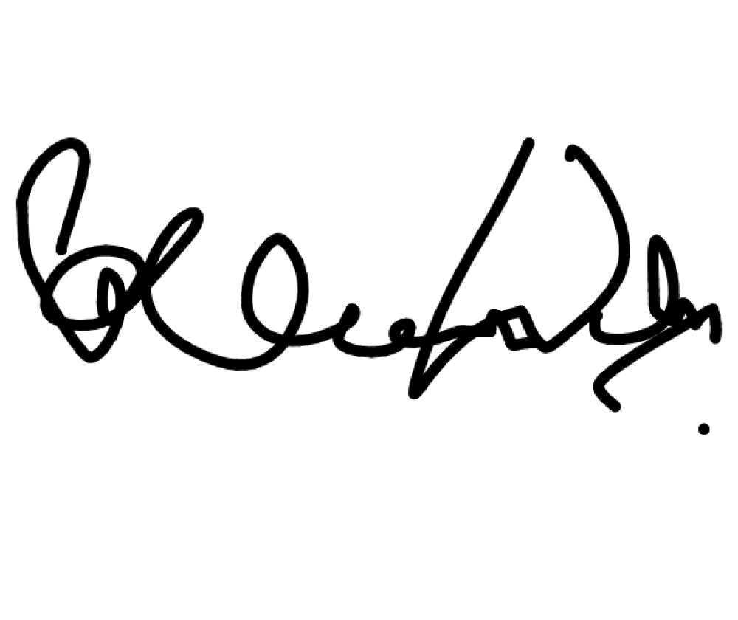
IN WITNESS WHEREOF, I have hereunto set my hand and the seal of the Village of Florida
(Name of Employer)
on this 9th
day of April
, 2025 ,

.
(Signature of Secretary or Clerk)
Affidavit of Posting: I, Colleen Wierzbicki

being duly sworn, deposes and says that the posting of the Resolution began on

(seal)

4/7/25

(Name of Secretary or Clerk)

and continued for at least 30 days. That the Resolution was available to the public on the:
(Date)
Employer’s website at: villageoffloridany.org
■

Official sign board at: 33 South Main St Florida NY 10921
■

Main entrance Secretary or Clerk’s office at Page 1
of 2

(for additional rows, attach a RS 2417-B form.)

Instructions for completing the Standard Work Day and Reporting Resolution

A | B | C | D | E | F | G | H | I | J
Name | Social Security Number | NYSLRS ID | Title | Current Term Begin & End Date | Standard Work Day | Record of Activities Result | Not Submitted | Pay Frequency | Tier 1
Elected Officials
John Smith | 0000 | R11111111 | Highway Superintendent | 1/1/2018-  12/31/2019 | 8.00 | 32.79 |  | Weekly
Michell e Jones | 1111 | R11111111 | Town Justice | 1/1/2018-  12/31/2018 | 6.25 |  | X | Bi-Weekly | X
Appointed Officials
Joseph Grey | 2222 | R22222222 | Planning Board Member | 1/1/2018-  12/31/2018 | 7.00 | 17.54 |  | Monthly

- Name: The official’s complete first and last name must be included for identification purposes.

- Social Security Number: The last four digits of the official’s Social Security Number must be included for identification purposes. For security purposes, the last four digits of the Social Security Number can be omitted from the publicly posted version.

- NYSLRS ID: The official’s NYSLRS ID must be included for identification purposes. For security purposes, the NYSLRS ID can be omitted from the publicly posted version.

- Title: All paid elected and appointed officials (who are active members of the Retirement System) and are not paid hourly and do not participate in a employer’s time keeping system that consists of a daily record of actual time worked and time charged to accruals must be listed. For the purpose of the regulation, an “appointed official” is someone who is appointed by an elected official, an appointed official or governing board. They hold an office in an organization or government and participate in the exercise of authority. This also includes appointees of elected and appointed officials such as deputies, assistants or confidential secretaries.

- Current Term Begin & End Dates: All officials listed on the Resolution must have a specified Term End date. Leaving this column blank or listing ‘Tenure/At Pleasure’ is not acceptable. If the official does not have a designated term, the current term for the official who appointed them to the position should be used. If they are appointed by the governing board, the chairman of the board’s term should be used.

- Standard Work Day: The minimum number of hours that can be established for a standard work day (SWD) is six, while the maximum is eight. A SWD is the denominator to be used for the days worked calculation; it is not necessarily always the number of hours a person works. For example, if a board member only attends one three-hour boarding meeting per month, you must still establish a SWD between six and eight hours as the denominator for their record of activities (ROA) calculation.

- Record of Activities Result*:This column must be left blank if an official does not submit their required sample three-month ROA. To determine the average number of days worked per month, you must divide the total number of hours documented on the three- month ROA by three months to get a one-month average number of hours worked. Then, the one-month average number of hours worked must be divided by the SWD to get the average number of days worked per month.

- Not Submitted: This column must be checked if an official has not submitted the required sample three-month ROA within the 150 day requirement, regardless of whether they are being reported by another employer for the same period. If the Retirement System receives such a Resolution, it will contact the official to notify them of the consequences of not submitted the ROA.

- Pay Frequency: This column should be filled in with one of the following options: Annually, Bimonthly, Biweekly, Monthly, Quarterly, Semi-annually or Weekly.

- Tier 1: If the official is a Tier 1 member, this box should be checked. Tier 1 members are not required to keep a ROA.

Once passed, the Resolution must be posted on your public website for a minimum of 30 days or if a website isn’t available to the public, on the official sign-board or at the main entrance to the clerk’s office. A certified copy of the Resolution and Affidavit of Posting must be filed with the Office of State Comptroller within 45 days of the adoption. The Resolution and Affidavit can be submitted via the Submit Resolution for Official link in Retirement Online.

*To determine the number of days worked to include on the monthly report for the various payroll frequencies, please refer to the Calculating Days Worked instructions available in the ‘Reporting Elected & Appointed Officials’ section of our website: http://www.osc.ny.gov/retirement/employers/reporting-ea-officials/overview

